Chapter 4, Problem 59.

Determine the Thevenin and Norton equivalents at terminals a-b of the circuit in Fig. 4.125.

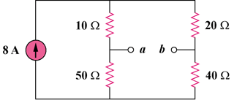

Figure 4.125
For Prob. 4.59.

